Antibiotic Review Kit (ARK) Implementation Guidance


Welcome!
Welcome to the ARK implementation pack! This guidance should contain all the information you need to implement ARK successfully in your hospital in a way that best fits your local needs. This guidance and the other resources you have been given are there to help, but we expect the ARK procedures will be implemented differently at each Trust. The ARK champion and Core Team will decide the best way to do this. What’s more, we hope you will share any local solutions you develop, through the ARK Champions’ Network, and through our research evaluation processes that you will be invited to take part in (e.g. questionnaires, focus groups, interview). This will help us continue to develop and improve ARK as it progresses.
The main aim of ARK is to get the decision aid categories (possible, probable, finalised) used in clinical practice.
There are four key activities that need to be implemented as part of ARK to help you do this. These are;
- Completion of the ARK online decision aid tool by prescribers and other relevant staff such as pharmacists and nurses. This explains to everyone concerned why and how to implement the ARK decision aid categories.
- Application of the ARK decision aid categories when writing prescriptions for antibiotics, if at all possible in the drug chart (in whatever way fits best locally), so that prescribers can easily see what category has been applied at initial prescription. As the ARK online tool explains, using these categories helps those carrying out antibiotic review feel more confident to stop antibiotics when appropriate.
- Data collection to check how ARK is being implemented (i.e. use of the decision aid categories, rates of review / stopping). This is to help identify any problems with implementation early on.
- Regular discussion with the wider clinical team about how ARK is being implemented (informed by the data collection). This is to encourage and support the wider clinical team in implementing the ARK decision aid categories, and help them address any problems with their implementation.
The implementation guidance provides detailed information and tips for each phase of implementation to help you find the best way to implement these activities locally. We recommend that you refer to it at each stage whilst planning and implementing ARK.
Remember that the ARK research team and Champions’ Network are available to help with any issues or questions you have.
Best wishes,
The ARK Research Team

Contents
Organisational Structure 4
ARK Tools 4
Key Implementation Activities 5
Phases of Implementation 5
Phase 1: Preparation: ARK Champions 7
Phase 2: Implementation Planning and Piloting: ARK Champion & ARK Core Team 11
Phase 3: Organise Kick-Off: ARK Champion and ARK Core Team 17
Phase 4: Get Ready for Implementation: All Staff 19
Phase 5: Implementation Starts: All Staff 22
Phase 6: Ongoing Implementation: All staff 23
Phase 7: Long-Term Sustainability: All Staff 26
Overview of Resources Website 28

Organisational Structure
ARK will be delivered as part of your Trust’s Antimicrobial Stewardship (AMS) work (see Figure 1). The AMS team should start by identifying who will be the Trust’s “ARK Champion”. The ARK Champion will lead on the implementation of ARK supported by other members of the AMS team, and important clinical staff identified by the Champion. Together they will form the “ARK Core Team”. Clinical teams should have an “ARK Clinical Team Lead” who will liaise with the ARK Core Team (but will not be involved necessarily in the planning of ARK).
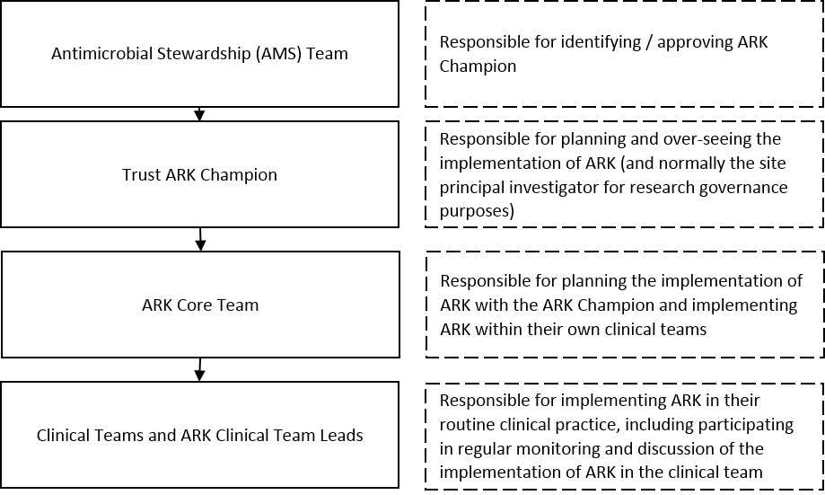
Figure 1: ARK organisational chart of staff and their responsibilities

ARK Tools
Three key tools are provided to support the implementation of ARK
- The Online tool (‘introduction’ and ‘decision aid’), which explains why and how to use the ARK decision aid categories
- A resources website for the ARK Champion and ARK Core Team (https://lifeguide.ecs.soton.ac.uk/player/play/resourcesv2)
- A patient leaflet that can be used to support review and revise decisions
The implementation guidance below will refer to some of the materials provided on the resources website (these will be highlighted in blue). However, the resources website will continue to be updated as more Trusts join ARK, and contribute new ideas for its implementation. You also can contribute to the resources website. If you have any materials that you would like to share once you have implemented ARK in your Trust, please contact orh-tr.ark-hospital@nhs.net. An overview of resources provided on the resources website can be found at the end of this document.

Key Implementation Activities
There are four key activities that must be completed as part of implementation in all Trusts.
- Completion of the ARK online tool (‘introduction’ and ‘decision aid’) by;
- The ARK Champion
- The ARK Core Team
- The wider clinical team. This includes:
  - Key members of the clinical teams who will be implementing ARK in their practice (e.g. AMU consultants). These individuals may take on the role of an ‘ARK Clinical Team Lead’ who will oversee the implementation of ARK in their clinical areas, but will not be involved in its planning. They will be responsible for supporting the implementation of ARK in their own teams through monitoring and discussion.
  - Clinical team members who will be using ARK (e.g. staff on AMU, staff on wards AMU refers patients onto).
  - This is not restricted to antibiotic prescribers but includes staff involved with the use of antibiotics in hospital e.g. pharmacists / nurses who don’t prescribe but support antibiotic prescription and review.
- Application of the ARK decision aid categories as part of antibiotic prescribing processes to acknowledge the presence of diagnostic uncertainty in initial prescribing decisions.
- Data collection to monitor the adoption and impact of the intervention.
A data collection tool is provided on the resources website to help you with this.
Note: This is primarily to support feedback to clinical teams, not for the evaluation of the intervention, which depends on electronic data supplied by the Trust to the trial team. However, we will also ask you to share this data with the research team so that we know how sites have gone about the data collection locally.
- Regular, supportive discussion with the wider clinical team on how to implement ARK successfully (based on latest monitoring data)

Phases of Implementation
There are 6 stages of implementation (see Figure 2). The first three phases focus on planning how to adapt ARK locally (phases 1-3), the next on preparing the wider clinical team for kick-off (phase 4), and the last two on implementation (phases 5-6). Detailed implementation guidance is provided in this document. There is also an implementation checklist on the resources website that you may find helpful to complete as you go through each phase.
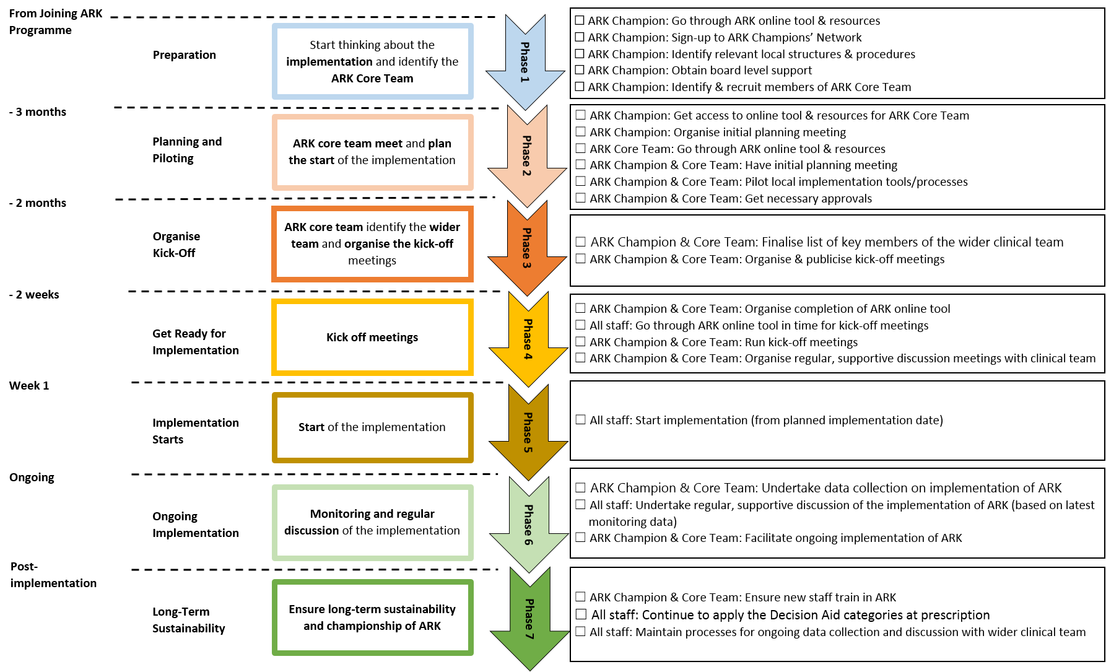
Figure 2: Summary timeline for implementation of ARK

Phase 1: Preparation: ARK Champions [From Decision to Join the ARK Programme]
Phase 1 – From Joining the ARK Programme
Core Tasks: Start thinking about how to implement ARK in your Trust and identify the ARK Core Team
- Familiarise yourself with ARK and identify useful implementation materials in resources
- List local procedures and how ARK would fit into existing structures
- Obtain board level support
- Identify members of ARK Core Team

Familiarise self with ARK and identify useful implementation materials in resources
ARK provides you with a number of resources to support you implementing “review and revise” in your Trust. These include: the ARK online tool (accessible online or via a mobile phone), the resources website, and the ARK Champions’ Network. You should familiarise yourself with this information prior to starting.
☐ Access the ARK online tool (email the ARK Research Team for a logon at orh-tr.ark-hospital@nhs.net) and read the introductory information and Decision Aid. Become familiar with the difference between a Probable diagnosis of infection vs a Possible risk from infection, and the evidence of lack of harm from shorter antibiotic courses. Decide if your hospital might benefit from taking part.
☐ Review the resources on the resources website and think about which one/s you could adapt and use to make “review & revise” more effective in your hospital (https://lifeguide.ecs.soton.ac.uk/player/play/resourcesv2).
☐ Sign up to the ARK Champions’ Network on the website (you can sign up here; https://www.jiscmail.ac.uk/cgi-bin/webadmin?SUBED1=ARKCHAMPIONS&A=1). Check when the next face-to-face champions meeting is and come if you can. It is important to attend at least one of the monthly teleconferences in the early planning stage as the Network provides crucial support at this stage. Once you have signed up, if you have any questions or challenges as you implement ARK, use this peer-support group (ARKchampions@jiscmail.ac.uk) to see if others already have answers. This will be a good source of information about how to implement the ARK categorisation system in different prescribing contexts (paper, electronic etc.).

List local procedures and how ARK would fit into existing structures
As much as possible, ARK should be embedded within already existing processes and structures within your Trust.
☐ Outline the flow of acute general medical admissions to your hospital, and where antibiotic prescribing other than stat doses are made.
- Where do patients go?
- Who is in charge of them for the first 72hrs?
- Which clinical teams (e.g. general medicine, acute medicine, surgery)?
- Who is at handover?
- Do A&E prescribers prescribe more than stat doses? If they prescribe more than stat doses then they will need to be included in ARK.
This information will help you to identify group representatives who should become members of the ARK Core Team, possible individuals to become ARK Clinical Team Leads, and which wards should be involved during data collection.
Phase 1 – From Joining the ARK Programme
Note: ARK is not designed for acute surgical inpatients, but if these are managed through the same pathway in your Trust there is no reason not to include them – think about what would work best for you in your Trust.
☐ Consider what processes already exist and what your local antibiotic guidelines are to support antibiotic “review and revise” decisions.
- How will ARK be implemented within these processes?
- Does ARK need to be linked into your Trust’s policies e.g. a local webpage or an app such as microguide, RXinfo, tap on the BUGS.
- Do the antibiotic prescription durations recommended in your policy need to be adjusted to fit in with the prescription categories in the ARK Decision Aid?
☐ Identify the main barriers that you think you will face implementing ARK in your Trust.
☐ List possible strategies that could be used to overcome these barriers (see resources website for some examples and suggestions of strategies you could adapt to your hospital and team).
☐ Think about how prescribers will record the ARK antibiotic prescription categorisation in the drug chart (initial antibiotic prescription as possible/probable, finalised prescription).
- Will you re-design your drug chart?
- Will you use a sticker on your paper drug chart? What size?
- Will you add a new box with the ARK categories to your electronic prescribing systems?
- Who needs to approve the system you want to use? This will be a major decision made in phase 2, but you may want to start discussions now, particularly if labels and charts need to be printed or electronic prescribing fields need to be adjusted.
- How will the ARK categories fit into the discharge process? Can antibiotic prescriptions be finalised before discharge?
If you are unsure about how you might be able to incorporate categorisation, discuss this with the ARK team / ARK Champions’ Network.
Examples materials from Trusts who have done this can be found on the resources website.
☐ Review your Trust’s “review and revise” audit data. Given that you are planning to use ARK to improve “review and revise” processes at your Trust;
- How do the data already show that better “review and revise” is needed? For example, audits may show that Review is happening for most patients, but is it effective at controlling unnecessary antibiotic use? What proportion of decisions are to stop?
- If you are not certain how accurate your data are, you could consider using the ARK data collection tool on a sample of patient prescriptions now or in phase 2. In Brighton, it was noted that existing data substantially over-estimated the proportion of prescriptions being stopped.
☐ Consider how you will monitor the impact of ARK. ARK recommends regular data collection about both the initial categorisation (Possible vs Probable) and the Review decision. This will help you identify, discuss, and address any implementation problems. ARK provides a data collection tool (on the resources website) to help you do this. This tool allows you to;
Phase 1 – From Joining the ARK Programme
- Record prescription decisions
- Automatically create summary tables
- Produce summary graphs and monitor progress towards “review and revise” targets

Obtain board level support
Demonstrable board level support will help improve uptake of ARK.
☐ List what board level support should be sought for the implementation and secure buy in (for example from the medical director, director of quality and innovation, director of infection prevention and control (DIPC), chief nurse, chief pharmacist, department of medical education), emphasising that ARK has the potential to substantially and safely reduce antibiotic use, benefit patients, meet quality measures and save money. Discuss whether being part of ARK could help your Trust (e.g. if it failed the CQUIN target). Involvement with ARK could help secure resources at the Trust to support stewardship activity. Could ARK be used as a quality improvement project?
☐ Investigate how the ARK online tool can be incorporated into your Trust’s learning and development programme. This could be as part of mandatory infection control or antibiotic stewardship training, or in consultant or other staff appraisals, as part of the workforce’s effort to improve antimicrobial stewardship. This will help to embed ARK as standard good practice to be carried out by all staff.
☐ Ask your Trust’s responsible officer how to get the ARK online tool included in the appraisal process.

Identify members of ARK Core Team
The ARK Champion should form a “Core Team” who will help plan and oversee the implementation of ARK in their clinical services.
☐ Identify and recruit the ARK Core Team. These may be members of the antimicrobial stewardship team with additional important individuals representing acute medicine, or other specialities, depending on your Trust’s structure. These staff will lead the implementation and act as mentors to other staff groups / grades. The team should include:
- The Trust’s antimicrobial stewardship (AMS) lead
- An antimicrobial pharmacist
- A microbiologist and / or infection specialist
- A medication safety officer, if you have one
- Senior clinical representatives from the clinical areas where ARK will be implemented. This should include:
  - An acute / general medicine consultant who will act as an ARK Clinical Team Lead (or possibly a consultant, from another speciality, depending on the flow of patients in your Trust)
  - A senior member of nursing staff
Phase 1 – From Joining the ARK Programme
- A specialist trainee (ST3+)
- A core medical trainee (CMT)
- A foundation doctor
- Anyone else you think might important to ensure the success of ARK in your hospital
- Is there a trainee who could be involved in ARK as a personal quality and improvement project and facilitate implementation on the wards?
Be clear that involvement in the ARK Core Team means being part of a national quality improvement initiative.

ARK in Practice
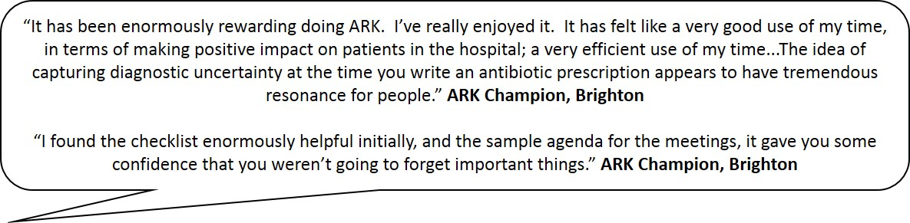

Phase 2: Implementation Planning and Piloting: ARK Champion & ARK Core Team [3 months before Implementation]
Phase 2 – 3 months until implementation
Core Tasks: Meet with the ARK Core Team, begin planning the start of implementation and test plans for implementation.
- Familiarise the ARK Core Team with ARK
- Hold an Initial Planning Meeting
- Pilot your Local Implementation Tools / Processes
- Get Necessary Approvals

Familiarise ARK Core Team with ARK
Before initial planning meeting:
☐ Invite ARK core team members to take part in ARK. Set up access to online tool.
☐ Organise the initial meeting with the core team to introduce and discuss adoption of ARK to support “review and revise” practices in your Trust.
☐ The ARK core team members should complete the ARK online tool and look at the resources website before the initial meeting.

Hold an Initial Planning Meeting
The initial meeting should be used to further familiarise the ARK Core Team with ARK and to start planning how ARK could be implemented into the Trust’s existing processes and structures. A suggested agenda is below (there is also a template agenda on the resources website). You may find it helpful to arrange for someone to take the minutes while you facilitate the meeting.
☐ Introduce and discuss the aims of ARK. Make sure the ARK Core Team are familiar with the difference between a Probable diagnosis of infection vs a Possible risk from infection, and the evidence of lack of harm from shorter antibiotic courses.
☐ Talk about how to implement the Decision Aid in the local context.
- How would prescribers use it?
- How would prescribing decisions be documented?
  - Will you redesign your existing paper drug chart to incorporate the decision aid categories?
  - Will you use stickers on a physical drug chart?
    - Consider how many stickers you might need based on typical volume of drug charts used
    - How will they be added to the drug chart? By who?
  - Will you adapt electronic prescribing (EPR)?
    - Could you use mandatory fields?
    - Could you use ‘power forms’ to document all antibiotic prescribing so that all prescriptions are documented in one place?
    - Could you get staff to write ‘possible’ / ‘probable’ when they document the indications (e.g. ‘possible’ UTI, ‘probable’ UTI)?
  - Could you get staff to write ‘possible’ / ‘probable’ in the patient’s notes when they document the indications (e.g. ‘possible’ UTI, ‘probable’ UTI) at initial prescription?
- How will staff manage “review and revise” over the weekend/bank holidays?
Phase 2 – 3 months until implementation
  - How will you encourage prescribers to include ‘review and revise’ in their weekend handovers?
- How could you use the patient leaflet with these processes?
  - At what point in their admission could it be given to patients?
  - Could the leaflet be used to support discussion with patients about their antibiotic prescription?
The idea that the first prescriber communicates their degree of confidence to the reviewer (by using the decision aid categories) is a crucial part of the intervention and this is why it’s very important to try to find a solution which allows the categories to be recorded on the prescription/drug chart. If the chart cannot be changed, and decisions recorded in the patient notes for example, then more educational activity and prompting will be needed to ensure the decision aid categories get applied, and rates of using the decision aid may be lower. Recording the decision aid categories on the chart will also make it much easier to gather the audit and feedback data. If it is not possible to change the drug chart in time for the start of implementation, consider whether it might be possible to do this later on and how you could get prescribers to apply the categories in the interim.
☐ Review data available on “review and revise” in your Trust or, if none available, you should do an audit to see what your Trust’s baseline levels of “review and revise” are. This will help you demonstrate to your team that “review and revise” procedures need to be improved and that reducing use of antibiotics is feasible. You could use the ARK data collection tool to collect this data or add in the ARK-specific fields into an existing audit that is already underway.
☐ Identify and discuss the main barriers (especially how to engage prescribers in acute and general medicine). Develop strategies to overcome these local barriers. List barriers and solutions on the ‘Potential Barriers & Solutions’ template. Please send a copy of this document to the ARK research team.
☐ Discuss how ARK will be launched and established into practice in your Trust. This includes publicising ARK, discussing how to support staff to complete the online tool before the kick-off meeting/s, and planning how ARK will be adapted locally.
- What forums exist to publicise and educate?
  - Are there any staff groups who may be difficult to reach (e.g. registrars on rotation, nurses, staff who may not have regular access to email)? How will you reach these staff?
  - Could you use existing training forums (e.g. mandatory training sessions, electronic systems) or existing staff meetings?
  - Could you alert staff by email? What email-lists exist? Who are these lists held by? Are there staff groups for whom there is no electronic system for communication?
  - Does ARK need to be linked into your Trust’s policies e.g. a local webpage, microguide, RXinfo, tap on the BUGS?
- How can you create a visible profile for ARK?
  - Can you do promotion events?
  - Could you use stickers / badges to identify staff involved with ARK who can be asked questions?
Phase 2 – 3 months until implementation
  - Could you put up posters to promote kick-off meetings and the online tool?
  - Could you use posters with tips on how to use the decision aid (once implementation starts)? Where should they be placed for maximum effect (e.g. nurses trolleys, desks where prescribers sit)
  - Could you promote the online tool with business cards with a tinyurl for the online tool?
  - Could you provide wards/staff offices with hand-outs for staff?
Example materials are provided on the resources website for you to adapt.
☐ Plan kick-off meetings. When and in what form will kick-off meetings take place (e.g. grand round, departmental/speciality team meetings, clinical governance meetings, teaching sessions for junior doctors/nurses/pharmacists (e.g. generic skills, mandatory training sessions). Be creative!
- Could you do kick-off meetings in pre-existing meetings for each team that will be involved with ARK (e.g. speciality meetings, professional group meetings)?
- Could you use the tailored presentations on the resources website for these different staff groups? Could they be presented by members of the Core Team or ARK Team Leads from these staff groups?
- Could you present example cases demonstrating how ARK will be implemented locally and how it differs from the existing system?
- Are there any groups of staff that might be missing from the existing structures for meetings (e.g. specialist registrars who may be on rotation)
- How will people attend kick-off meetings around their shift patterns? Could you organise a second meeting to allow people to attend around their shifts?
- Are there F1/F2/CMT training events you could use?
- Are there forums specifically for nurses and pharmacists (e.g. matrons’ meetings)?
- Could you use the short pre-shift meetings to promote ARK around kick-off?
- Are there any upcoming bank holidays / ARK Core Team annual leave you need to plan around?
☐ Discuss how you will gather data to assess the adoption and impact of the ARK. We would encourage you to use the ARK data collection tool, which quickly produces powerful data for discussion. There is also a data collection guide with tips to help you with this.
- Decide on where data should be collected from in addition to AMU. This should be based on the flow of patients in your hospital from AMU, i.e. where the Review decision takes place.
- Decide who will be responsible for data collection on the implementation of ARK in each team using the tool.
  - Would your ward/antimicrobial pharmacist/s help with this?
  - Would this be a responsibility of junior doctors on each team (e.g. as a quality improvement project) supervised by one of the ARK Core Team to ensure continuity?
  - Could it be a quality improvement project for the ARK Clinical Team Leads?
Phase 2 – 3 months until implementation
  - Could it be an audit project in its own right? Or could you add the ARK-specific data fields into an existing audit that is undertaken regularly?
- You should collect data on;
  - Use of the decision aid at initial prescription;
    - Was it used?
    - What categories were used?
  - Whether “review and revise” took place;
    - Did review happen within 72 hours of initial prescription?
    - What was the outcome? Continue? Stop?
These data can be from different groups of patients, i.e. from two separate surveys (see below).
- Decide on how the data will be collected.
  - ARK recommends a ‘point prevalence’ survey focusing on current prescriptions on the relevant wards, rather than tracking the outcomes of “review and revise” in a specific sample of patients (unless you particularly want to do individual case studies). Our experience of doing this found that it can be extremely difficult following up patients as they move between multiple wards and are discharged.
  - We recommend sampling all patients on the ward who have been prescribed antibiotics in whom the decision tool should have been used.
  - Our experience is that it takes approximately 45 minutes to 1 hour to process 20 prescriptions (at least at the beginning).
- Decide on how frequently data will be collected. This needs to be often enough to build understanding of the new approach with the clinical teams but requires enough data to give informative feedback (e.g. 15-20 prescriptions). ARK advises weekly / two weekly for the first 1-2 months and monthly thereafter. This will help you identify any problems with implementation early on in the process.
- Discuss how targets will be monitored (e.g. by whom, when). ARK aims to have;
  - 80% or more antibiotic prescriptions with the Decision Aid classifications documented at the initial prescription.
  - 90% or more antibiotic prescriptions with “review and revise” documented.
  - At least a doubling in the percentage of antibiotic prescriptions stopped at “review and revise”, or achieving 30%.
☐ Discuss how you will regularly, and supportively discuss the results of the data collection with the wider clinical team. This should be led by someone in the clinical team who takes on the role of the ‘ARK Clinical Team Lead’ or someone from the ARK Core Team. Discussing these results with the wider clinical team is an important tool to let them know how well ARK is being implemented, and to prompt discussion around potential barriers to its implementation.
- Talk to the clinical teams early on about what would be the best way to feedback to clinical staff on the ground (not just to senior management).
- You should use multiple ways of feeding back this information to clinical teams.
- Plan to have face-to-face discussions with the clinical team about how ARK is being implemented. This is vital as it will keep the team engaged with ARK and provide a forum to identify, discuss, and address potential barriers to implementation. You could use;
Phase 2 – 3 months until implementation
  - Quick discussions to touch base with staff, e.g.,
    - Ward rounds
    - Huddles
    - Handover meetings
    - Off-the-cuff meetings with on-duty ward doctor immediately following data collection if it is identified that prescriptions should have been done but haven’t
    - Team governance meetings
  - Teaching meetings
  - Longer meetings to discuss in more depth how ARK is being implemented. A template agenda for ‘ongoing discussion meetings in phase 6’ can be found on the resources website
- Could you use supplemental materials to help support your discussions with the clinical team?
  - Are there whiteboards or dashboards that could be used to let people know how the implementation is working?
  - Could you send updates by email?
  - Could you provide handouts?
  - Could you show slides on a Trust laptop?
  - Use multiple formats – e.g. verbal, written, visual (e.g. graphs from data collection tool can be helpful to convey information quickly and simply to your team).
- How frequently will you discuss the implementation of ARK with the clinical team? Exactly how frequently you do this depends on your patient flow; you probably need 15 -20 patients in each batch you feedback on for the numbers and percentages to be meaningful). Results of the data collection should be discussed in a timely manner (weekly or fortnightly).
☐ Discuss how to make ARK sustainable in your Trust in the long term.
- What mechanisms will support staff to use the Decision Aid in the next months and integrate it into their routine practice?
- How will new staff (particularly, new medical staff) be taught to use the Decision Aid?
- Can ARK be incorporated into the induction process and/or mandatory or general skills training?
☐ Agree on the specific roles of the core team members for Phases 3, 4, 5 and 6. What tasks can be delegated to members of the Core Team? Specific tasks might include;
- Revising drug charts to add ARK categories
- Piloting new materials (e.g. modified drug charts)
- Piloting the planned local implementation
- Piloting the data collection tool
- Presenting at the different kick-off meetings
Identifying potential cases studies to illustrate how ARK could be used in practice comparing current processes to how it would work with ARK
Phase 2 – 3 months until implementation
☐ Arrange ongoing Core Team Meetings
- Set clear objectives for completion between meetings
- Identify and overcome barriers
- Maintain engagement
- Agree on deadlines

Pilot your Local Implementation Tools / Processes
Once you have decided on the best way/s to implement ARK in your Trust, the ARK Core Team should pilot the process/materials. It is particularly important to pilot the way you decide to record the Decision Aid classification before implementation. Piloting should be confined to the Core Team only to prevent uptake of ARK prior to the implementation date.
☐ Pilot local implementation process/tools (ARK Core Team only)
- We recommend piloting using at least 10 patient prescriptions considering different areas that acute medical patients end up in the Trust.
- You should allow at least 3-4 weeks to pilot and test revisions.

Get Necessary Approvals
Get any necessary approvals for integrating ARK tools into practice.
☐ Integrate the Decision Aid into the existing prescription system
☐ Consider if you need to get approval for use of the Patient Leaflet. Whilst ethics approval has already been obtained for the patient leaflet, you should check whether your Trust will want to approve the use of these materials before you start using them (e.g. drug and therapeutics committee). If your Trust would like to use the leaflet more generally it is fine for them to add your Trust logo to it.
☐ Obtain learning and development office approval for ARK online tool, and arrange for it to be considered as CPD if possible

ARK in Practice
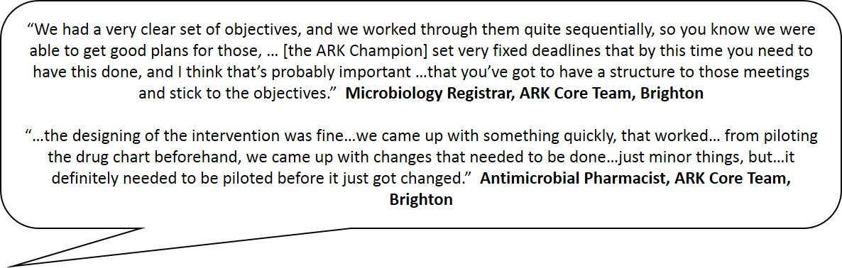

Phase 3: Organise Kick-Off: ARK Champion and ARK Core Team [2 Months before Implementation]
Phase 3 – 2 months until implementation
Core Tasks: Identify key members of the wider clinical team and plan kick-off meetings
- Identify key members of the wider clinical team
- Organise & publicise kick-off meetings

Identify key members of the wider clinical team
Identify those members of the wider clinical team who will be integral to implementing ARK into routine practice once implementation starts. They should include prescribers who will be applying the decision aid categories at initial prescription and will be undertaking ‘review and revise’, as well as non-prescribers who will support these processes.
☐ Write a list of all the members of the wider clinical team who are involved with prescribing for acute medical patients at your Trust, including those in charge of the patient 48-72 hours after the initial prescription (e.g. AMU, general medicine, specialist consultants, AMU and medical wards nurses and pharmacists). These are the people that you want to ensure will take part in ARK. This list may also include;
- specialist trainees
- physicians from respiratory, gastrointestinal, gerontology specialities, or others from wards AMU refers onto
- pharmacists and nurses who have key roles in these clinical areas
From this list, select 20-30 key members who would be actively engaged and willing to help implement ARK. These people will be key to the implementation. The names and email addresses of these key members will need to be logged with the ARK research team. You will need to save these details in a word or excel document and send it to the research team at orh-tr.ark-hospital@nhs.net.
☐ Make a list of other people who might be interested in completing the online tool and invite them to take part in the kick-off meetings.

Organise and Publicise Kick-Off Meetings
Organise kick-off meetings with all the different stakeholder groups. These should take place in the 2 weeks before your planned implementation date.
☐ Organise and publicise kick off meetings with the clinical teams who should be involved in the intervention (consultants, specialist trainees, junior doctors, nurses, pharmacists, from Acute/ General Medicine and other relevant specialties depending on your patient pathway).
- Think about how you could promote the kick-off meetings
  - Are there existing email-lists you could use?
  - Could you get reminder emails sent by other Trust leaders e.g. medical director?
  - Could you do publicity events?
  - Could you promote ARK at existing meetings?
  - Could you get team leads of the relevant teams involved early on so they can endorse it to their teams at kick-off?
  - Could you hand out summaries to doctors and nurses?
Phase 3 – 2 months until implementation
- Think about how you could organise the kick-off meetings:
  - One possibility would be to have one large kick-off meeting at a Grand Round, and then organise smaller meetings as well
  - Think about using slots at existing team meetings (e.g. AMU, and other relevant wards) and healthcare professional meetings (e.g. consultants, pharmacists, trainee meetings). Plan in advance to get a slot (allow about 20 minutes for this).
  - Make sure the internet will be working in the venues where you hold the kick-off meetings – if people haven’t looked at the ARK online tool before the meeting, they can do it during the meeting.
There is a kick-off meeting email template on the resources website that you can use to advertise the meetings, as well as one-side introductions in the example materials that you could send out with these emails (but remember not to include hyperlinks to the online tool as it is too early to advertise the online tool at this point!). There are also PowerPoint presentation slides for grand round meetings and a tailored presentation for smaller team meetings.

ARK in Practice
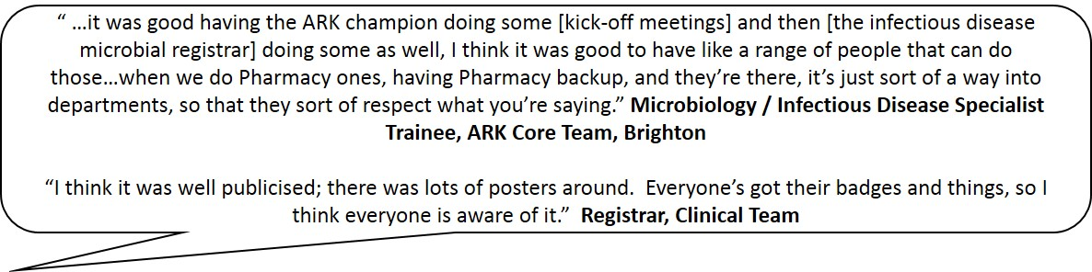

Phase 4: Get Ready for Implementation: All Staff [2 Weeks before Implementation]
Phase 4 - 2 weeks until implementation

Core Tasks: Kick off meetings and completion of the online tool
- Organise completion of ARK online tool as CPD
- Remind staff to complete the online tool before the kick-off meetings
- Run kick-off meetings
- Arrange regular discussion meetings with the clinical team

Get staff to complete the online tool before the kick-off meetings
☐ Get staff to complete the online tool before attending the kick-off meeting. Kick-off meetings will be much easier if people have completed the ARK online tool prior to the meeting and understand the rationale for ARK and the use of the decision aid categories.
- Email links to the online tool prior to the kick-off meeting (emphasising it will take approximately 10-15 minutes to complete). Email templates can be found on the resources website.
  - Send out links to the website version and the version that can be downloaded on android / iphone
  - Remind staff that if they cannot download it then they can still get access to the website version using internet browsers on their PC and mobile phone
- Are there other ways you could promote completion of the online tool (e.g. tinyurl business cards, posters) during this period?
- Remind staff that they will receive a certificate that they can add to their CPD portfolio after completing the online tool.
☐ Send out a second reminder to staff about completing the online tool just before the kick-off meetings.

Run kick-off meetings
Kick-off meetings are used to review ARK with the wider clinical team and discuss local implementation, including the date when you will start using it in your Trust.
☐ Present the national and local rationale for ARK drawing on the slide-set provided and ARK online tool / resource website materials. Amend these for your local use by adding your local audit data so as to demonstrate to your team how “review and revise” procedures need to be improved and that reducing use of antibiotics is feasible. You can also use your local ESPAUR data which can be downloaded from the ‘fingertips’ PHE website. Be familiar with the Q&A which covers common questions that may be raised.
☐ Make sure everyone has completed the ARK online tool. Although ideally people will have completed the online tool before the kick-off meeting, in practice some people won’t – encourage those who have not yet completed the material to access it as part of the kick-off meeting. Send out a reminder to complete the tool, for those who haven’t done so, after the meeting. This will keep it in people’s minds if they didn’t have time to finish it during the meeting, and will emphasise the importance of completing the online tool.
☐ Discuss how to use the Decision Aid in local practice.
☐ Explain how ARK will be established and monitored.
Phase 4 - 2 weeks until implementation

- Explain that there will be regular discussion meetings and ward rounds/huddles (small get together at the start of each ward round) about how ARK is being used in practice.
- Explain to prescribers why and how often these discussions will take place – weekly for the first month, then every other week until three months, then monthly.
- Explain that the data will be collected to support the implementation and will be fed back to teams by the ARK Clinical Team Leads.
- Discuss targets: >80% of antibiotic prescriptions with the Decision Aid classifications documented, >90% of antibiotic prescriptions with “review and revise” documented, at least a doubling in % antibiotic prescriptions stopped at “review and revise” (or achieving 30%).
- Give examples illustrating how ARK might be successfully applied in practice, and where it might be tricky (check examples on online tool).
- Openly discuss the fact that some patients who stop antibiotics will need to restart them if their clinical condition changes or more information becomes available.
☐ Discuss potential barriers to ARK with the team, so that the team’s concerns are acknowledged and addressed before implementation starts.

Arrange regular discussion meetings with the clinical team
Regular discussion meetings will be used to discuss how ARK is being implemented and to give feedback to the clinical team on its implementation. These meetings will be an opportunity to discuss and problem solve any difficulties with implementation. They will include discussion of data collection results, case examples of when ARK categories have worked well, and when they have been tricky to use, as well as ways to improve implementation. This feedback is for everyone involved in ARK who attended the kick-off meetings – it is not aimed at the ARK Core Team or Board level, but those involved in using the ARK tools on a daily basis.
☐ Agree and organise regular discussion meetings with clinical teams on the ground to monitor performance (at individual or group level) and the rates of antibiotic prescribing. These should be led by the ARK Clinical Team Leads, who will liaise with the ARK Core Team or a member of the ARK Core Team. It can be hard to get people together so this will need to be planned in advance.
☐ Agree and organise stewardship ward rounds / huddles to monitor the staff awareness and use of the Decision Aid. These may be led by members of the ARK Core Team or the ARK Champion.

ARK in Practice
Phase 4 - 2 weeks until implementation

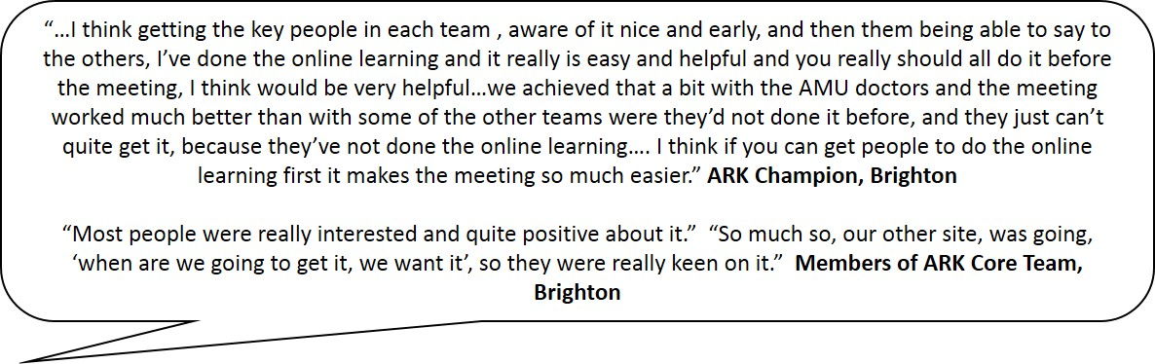

Phase 5: Implementation Starts: All Staff [week 1]
Phase 5 - implementation starts

Core Tasks: Start implementation

Start implementation
As part of the kick-off meetings, the ARK Champion will explain when ARK will be implemented in your Trust. This should be very shortly after staff have completed the online tool and attended the kick-off meeting. From this date they should start using the ARK decision aid and its categories when starting / revising prescriptions and when undertaking review.
☐ Start using decision aid in routine practice from the planned implementation date

ARK in Practice
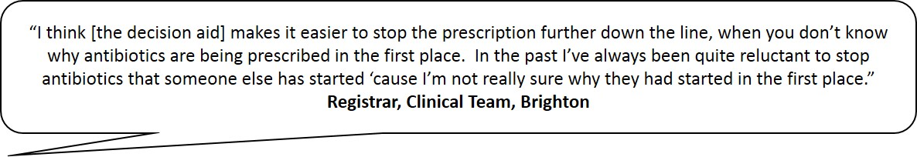

Phase 6: Ongoing Implementation: All staff [week 1 onwards]
Phase 6 - ongoing implementation

Core Tasks: Collect objective evidence on the implementation of ARK in your hospital to facilitate regular, supportive discussion with the wider clinical team about how ARK is being implemented in order to support them implementing ARK in their routine practice.
- Collect objective evidence on how ARK is being implemented
- Facilitate regular supportive discussion with staff about how ARK is being implemented
- Facilitate ongoing implementation of ARK
- Complete Implementation Checklist

Collect objective evidence on how ARK is being implemented
The Decision Aid will be most effective if supported by on-going data collection with prompt, targeted, and specific feedback to the wider clinical team. Regular data collection will help you monitor how ARK is being implemented to help you identify any problems early on, and keep track of targets. You can use the ARK data collection tool to present these data in graph format to allow comparisons over time. There is also a guide for data collection with tips to help you with this.
☐ Undertake regular data collection on how ARK is being implemented on different wards/in different teams. ARK advises collecting data on a weekly basis for the first month, fortnightly for the second month, and monthly thereafter.
- What percentage of prescriptions are being categorised using the Decision Aid?
- What categories are being used at initial prescription?
  - Are the possible and probable categories both being used?
  - Are certain teams tending to use the possible category less? This may make it harder for people reviewing the prescriptions to stop them
- What percentage of prescriptions are being reviewed within 72 hours?
- What percentage of prescriptions are being stopped?
☐ Look at how current rates compare to baseline rates of review & revise. How have rates of review / stopping changed since ARK was implemented?
☐ Look at how close you are to reaching the ARK and CQUIN targets. How do current rates compare to those observed in the previous data collection? Is there room for improvement?
Whilst this evidence is used primarily to support regular, supportive discussion with the team about how ARK is being implemented, this data will also be helpful to the research team so that we know how sites have gone about the data collection. Please remove all patient identifiable information (e.g. hospital number, date of birth) from the data collection tool before sending it to us.
☐ Send anonymised copies of data collection tool to the research team at orh-tr.ark-hospital@nhs.net. Please delete columns containing hospital number and date of birth (DOB) prior to sending.

Facilitate regular, supportive discussion with staff about how ARK is being implemented
In hospital practice where prescribers work in clinical teams it is most appropriate for feedback to be at the team-level. Being seen on the ward will help maintain awareness of ARK, support staff to implement it, and give staff the opportunity to discuss any difficulties.
☐ Provide regular, supportive feedback to wider clinical team regarding the implementation of ARK based on the evidence from the data collection (e.g. at ward rounds, huddles).
Phase 6 - ongoing implementation

- This discussion should be timely, following soon after the data has been collected. Discussion should be facilitated by the ARK Clinical Team Leads.
- Always start by congratulating the team on what is going well (e.g. achieving or maintaining progress since the previous week in using the decision aid categories / review / stopping). If you are providing written information, order this information in a similar way.
- You should aim to do these in as little as 5-7 minutes in an existing meeting, focus on brief positive feedback based on data collection and present a couple pf streamlined case studies that staff can learn from covering the basic information e.g. patient symptoms, diagnosis, whether antibiotics were stopped / not.
☐ Discuss with the clinical team how the decision aid, and “review and revise” is being used in practice. For example;
- Are there any differences between weekdays and the weekend?
- Are there any barriers that need to be addressed?
☐ Discuss specific recent situations taken from daily practice to stimulate discussion of how to implement the Decision Aid. These discussions should focus on a) positive examples of good practice, b) examples of how to overcome barriers to implementation, and c) examples of success in using the Decision Aid to safely reduce antibiotic use. These could include cases illustrating:
- Where the Decision Aid has helped antibiotics to be stopped safely
- Where the Decision Aid was not used but should have been
- Where antibiotics were stopped and later had to be restarted without clinically significant harm.
A template is provided on the resources website to help facilitate these meetings.

Facilitate ongoing implementation of ARK
Ensure that ARK is sustained in the longer-term following its implementation.
☐ Hold regular meetings with ARK Core Team to monitor and discuss implementation, in order to address any barriers to implementation as they arise.
- As questions and challenges arise, please share them with the ARK Champions’ Network, and help other ARK Champions if you can as they also implement ARK in their Trust.
- We will hold periodic face-to-face ARK Champions’ Network meetings which we would really value everyone’s participation in.
☐ Ensure new staff train in ARK.
- Monitor and promote ongoing use of the online tool by new staff.
- Think particularly about changeover day and induction of incoming staff (including doctors, nurse, and pharmacists). Inclusion of the ARK online tool as part of mandatory training / induction will help with this.
Phase 6 - ongoing implementation

☐ Provide adequate handover in the event of staff changeover of ARK Champion or Core Team.
☐ Plan for ongoing data collection and discussion with wider clinical team. To make sure that everyone continues to use the ARK methods to successfully reduce antibiotic use it is important to continue data collection on a regular basis (e.g. monthly) - but you can decide how often to carry out data collection depending on how well implementation is going (with more frequent monitoring if implementation is going less well). This does not need to be done by the same people as during the implementation phase – for example, in Brighton this is now being successfully done on an ongoing basis by a trained pharmacy technician.
- Could monitoring and discussion be embedded into practice as an ongoing junior doctor’s project?
- Could it be set up as a regular audit?
- Is there a pharmacy technician who could take on this role?
- Could you run a second grand round to give feedback on ARK to promote its ongoing use and raise awareness about its impact?

Complete Implementation Checklist
To get a better understanding of how ARK is being implemented in each Trust, please complete the Implementation Checklist once you have finalised your implementation procedures and send a copy to the ARK research team.
☐ Complete the Implementation Checklist and send a copy to the ARK research team once your implementation procedures are finalised (orh-tr.ark-hospital@nhs.net).

ARK in Practice
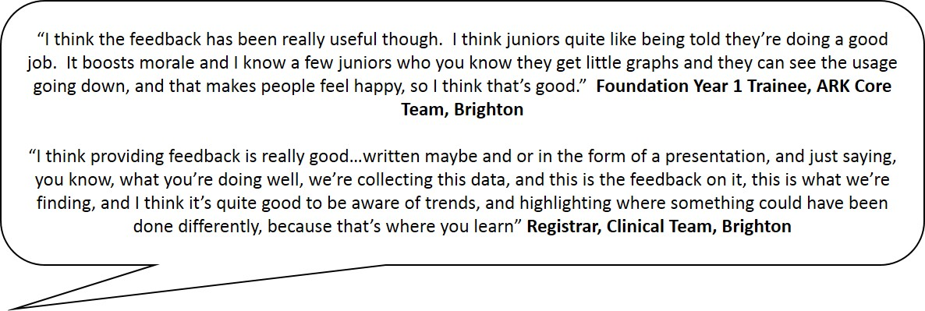

Phase 7: Long-Term Sustainability: All Staff [Post-Implementation]
Phase 7 – long-term implementation

Core Tasks: Ensure that ARK is embedded in antibiotic prescribing practice in the long-term, and becomes a routine part of patient management.
- Ensure new staff complete the online tool
- Ensure staff continue to apply the decision aid at prescription
- Maintain processes for ongoing data collection and discussion with the wider clinical team
- Ensure ongoing championship of ARK

Ensure new staff to complete the online decision aid tool
If you haven’t already done so, one of the best ways to ensure staff understand what ARK is and how to apply the decision aid is to get ARK included in your Trust’s learning and development programme; ideally this would be via completion of the ARK online decision aid tool, which staff will get a certificate of completion for.
☐ Get the ARK online decision aid tool included in your Trust’s learning and development programme. This could be as part of;
- Induction
- Mandatory training (e.g. infection control)
- Junior doctor training (e.g. F1 programme)
- Other training events (e.g. for nurses/pharmacists)
☐ Get ARK included in face-to-face training sessions.
- You could adapt the ARK kick-off meeting slides for these events.
- If it cannot be directly included in a relevant session, see if you can get it promoted in the session instead
- Provide links for the online training and mention that the online training is certificated and recognised by the following organisations; British Infection Association, SAM, British Society for Antimicrobial Chemotherapy, Clinical Pharmacy Association, Pharmacy Infection Network.
☐ Alternatively, try to revisit ARK at other events at key times of the year (e.g. when junior doctor rotation occurs). This could be at;
- Grand rounds
- Academic days
Now that ARK is established, you could draw on other collegues to help you with this.

Ensure staff continue to apply the decision aid categories at prescription
If you haven’t already done so, one of the best ways to ensure that the decision aid categories continue to be applied at prescription is to ensure that the decision aid is part of the prescribing process.
☐ Get the ARK decision aid incorporated into your Trust’s drug chart or electronic prescribing system.

Maintain processes for ongoing data collection and discussion with the wider clinical team
Phase 7 – long-term implementation

If you haven’t already done so, you should set up processes for ongoing data collection and discussion with the wider team. This will enable you to continue to monitor and address how ARK is being used after the initial implementation phase, and ensure it continues to be used routinely.
☐ Identify who will be responsible for ongoing data collection.
- Could monitoring be embedded into practice as an ongoing junior doctor’s quality improvement project?
- Is there a pharmacy technician who could take on this role? This has worked well at other Trusts who have implemented ARK.
☐ Agree how frequently data should be collected. This could be monthly, quarterly, or even less frequently, if ARK is going well. However, it should be more frequent if ongoing maintenance and use of the ARK intervention is going less well. This is so that you can monitor what is happening more closely, and have data to feedback to the wider clinical team, so that you can address any issues with using ARK.
☐ Agree how data will collected.
- Could it be set up as a regular audit?
- Could it be incorporated into an existing audit (e.g. CQUIN)?
☐ Agree who will feedback to the clinical teams about the ongoing implementation of ARK.
- Could you run another grand round to give feedback on ARK, to promote its ongoing use and raise awareness about its impact?
- Could you arrange periodic updates with the main clinical teams about antibiotic prescribing on their wards?

Ensure ongoing championship of ARK
ARK should be a continuing part of antimicrobial stewardship.
☐ Ensure long-term sustainability of ARK is kept under review by the Antimicrobial Stewardship team.
- Should it be a standing agenda item at Antimicrobial Stewardship team meetings?
☐ Ensure that a new ARK champion is appointed in the event of staff changeover. This should be a member of antimicrobial stewardship team.

Overview of Resources Website
Below is a summary of the resources that are available on the resources website (https://lifeguide.ecs.soton.ac.uk/player/play/resourcesv2). However, the resources website will continue to be updated as more Trusts join ARK.
RESOURCE | DESCRIPTION
Implementation checklist | Checklist for documenting which steps you have taken in each phase of implementation.
Data collection tool | Excel document to capture data on use of decision aid categories at initial prescription, and actions taken at review. Automatically produces summary tables and graphs
Phase 2 – Initial Planning Meeting with Core Team - Agenda | Template agenda for the initial planning meeting with the ARK Core Team
Phase 2 – Barriers and Solutions Template | Template (with example) for identifying and addressing barriers to ARK
Phase 3 – Kick-Off Meeting – Email | Email template for advertising ARK kick-off meetings
Phase 4 – Grand Round / Kick-Off Meeting - Email | Email templates for advertising ARK online tool when advertising grand round / local kick-off meetings
Phase 4 – Kick-Off Meeting - Agenda | Template agenda for kick-off meetings with wider clinical team
Phase 4 – Kick-Off Meeting - Slides | PowerPoint slides for kick-off meetings, including grand round slides, and a shorter slide set for shorter meetings
Phase 6 – Discussion Meetings with Wider Clinical Team - Agenda | Template agenda for 5-minute discussion meetings with wider clinical team about implementation of ARK
Example material – Drug charts | Example drug charts that have been adapted for ARK
Example material – Posters | Example posters, including a ‘doctors tips’ poster, nurses trolley poster
Example material – Handouts | Introductory handouts for medical and nursing staff
Example material – Example Cases | Additional case examples of applying ARK categories (‘possible’, ‘probable’) to initial prescriptions
ARK-Hospital – Experiences | Slide sets describing other site’s experiences adapting and implementing ARK
Q&A | Common questions and answers

